CSC455 – Computer Vision
Group Members:
Name | ID
Aoun Haider | FA21-BSE-133
M Talha Shafique | FA21-BSE-152
Muneeb Zahid | FA21-BSE-091
CLO:<03>; Bloom Taxonomy Level:<Applying>
Task 1:
Importing required libraries:
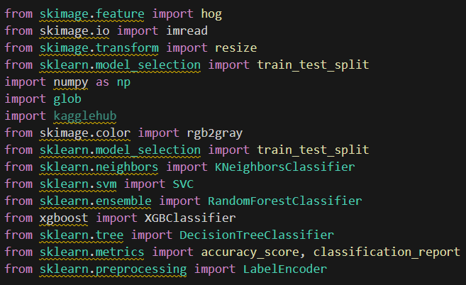
Download the dataset from Kaggle:
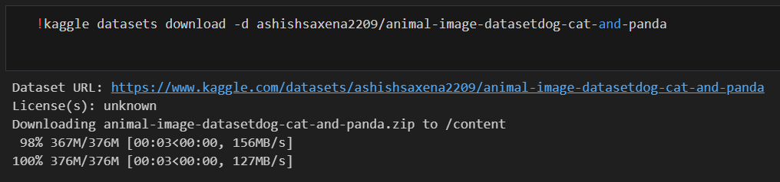

Extract the content of zip file:
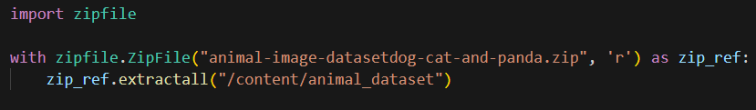
Loading dataset and computing HOG feature vectors:
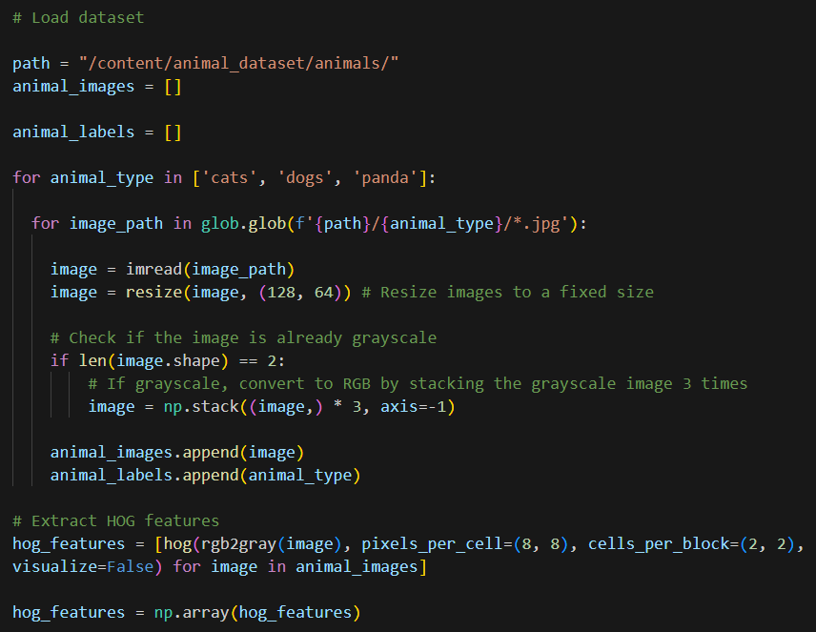
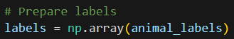

Apply ensemble learning with techniques KNN, SVM, Random Forest, Decision tree, Xgboost:
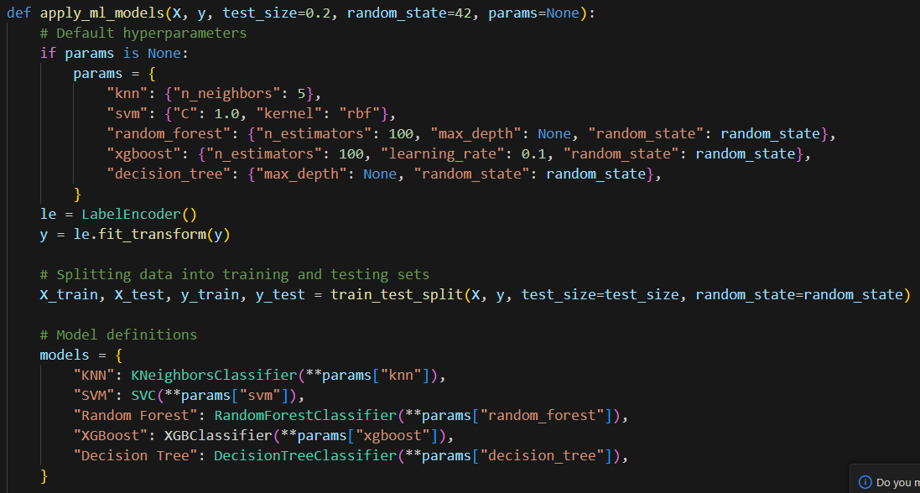
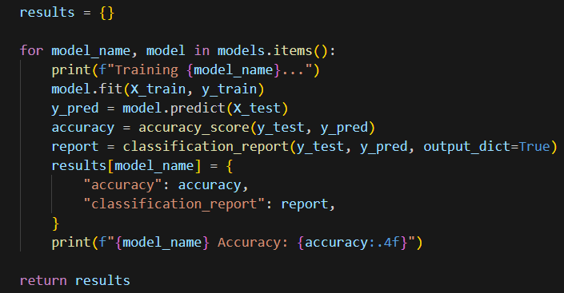

Determining the accuracy of each individual algorithm:
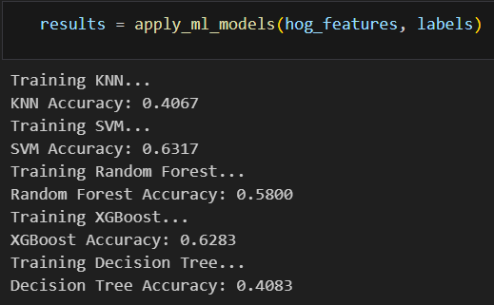
Findings: SVM provided the highest accurate rate of 0.63 or 63%
Task 2: <Animal Detection>
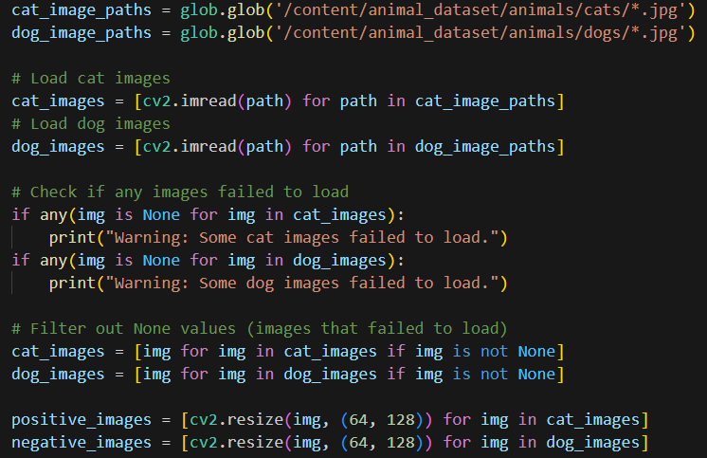
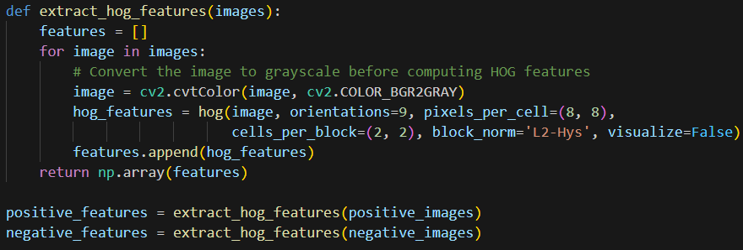
Training, testing & accuracy:
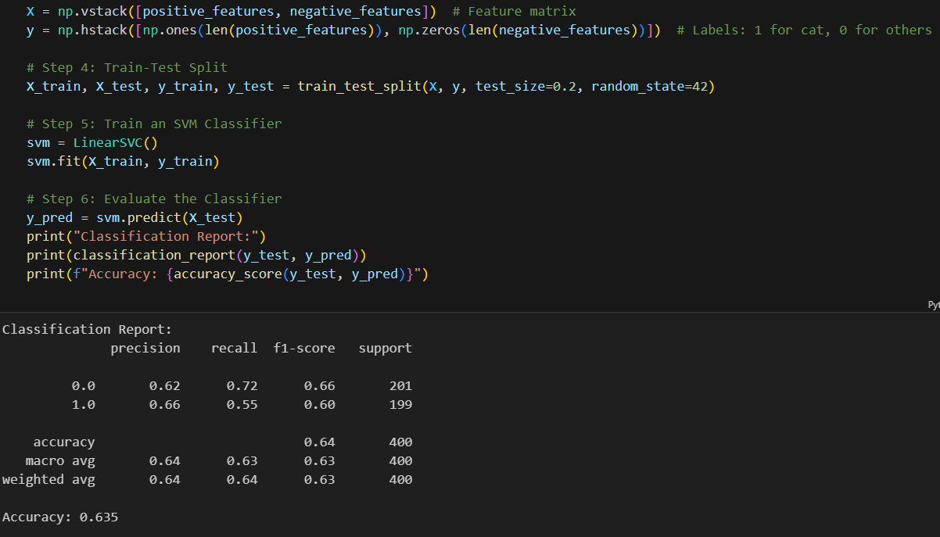
Task 3:
Training Artificial neural network (ANN):
Data pre-processing: Label encoding
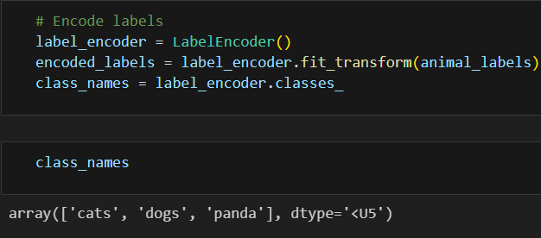
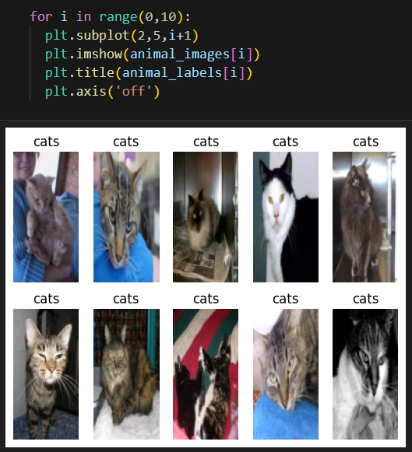

Analysis:
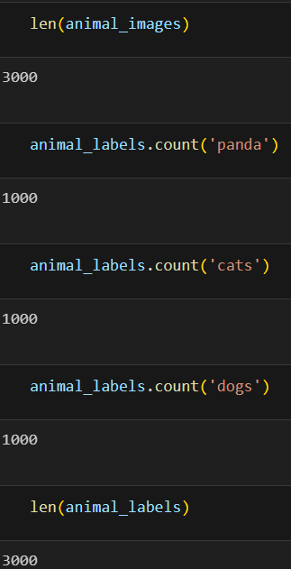
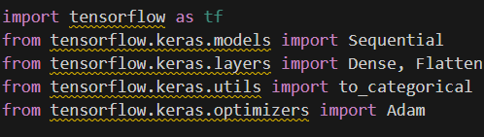

Training dataset:
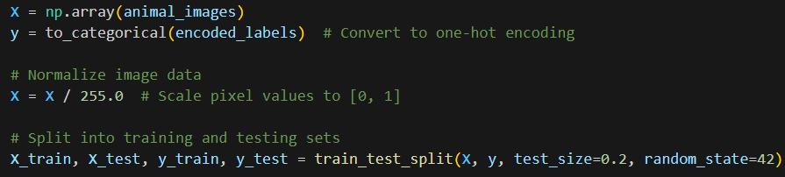
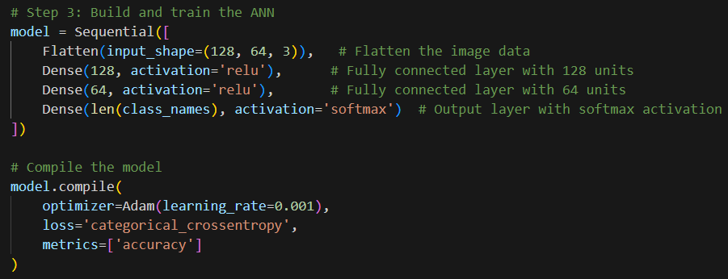
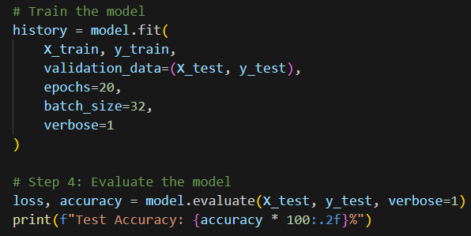
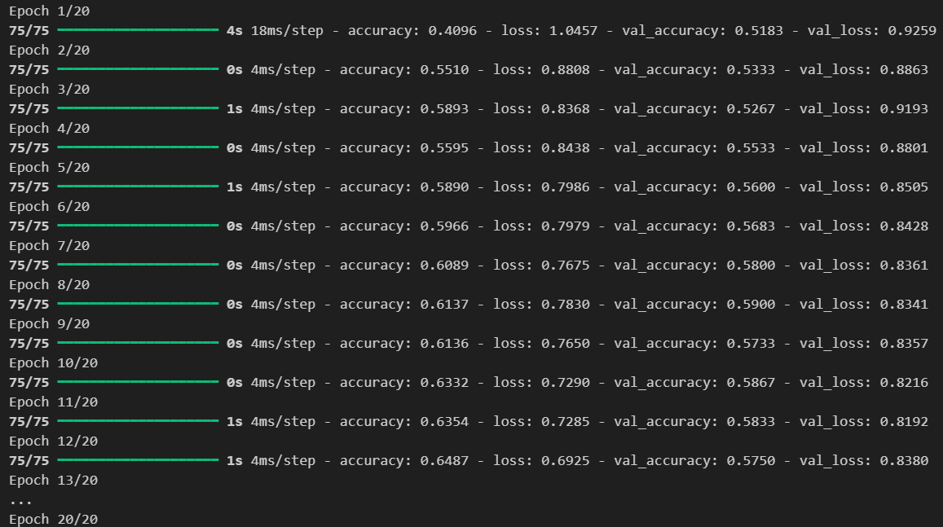
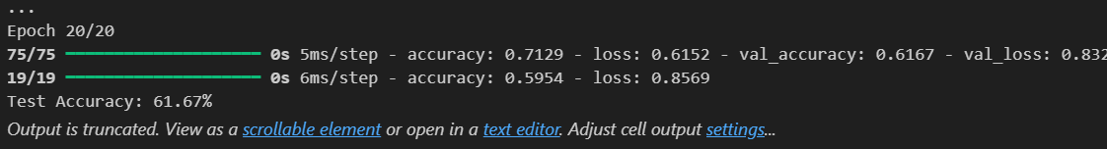

Prediction:
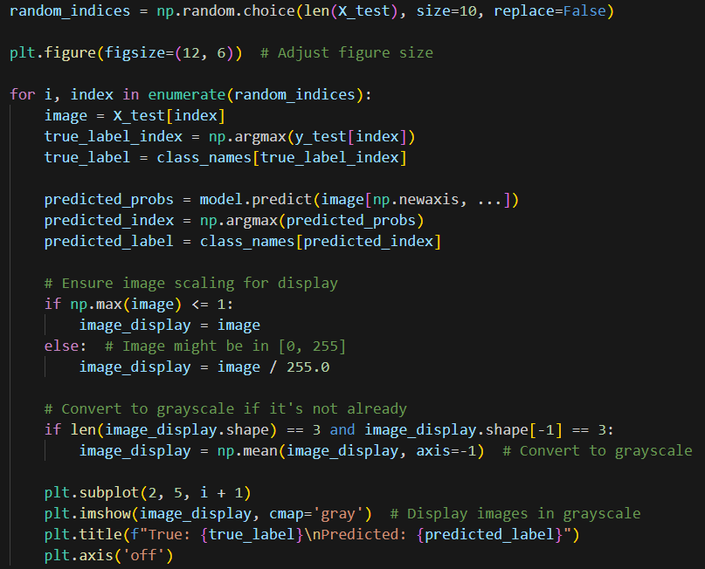
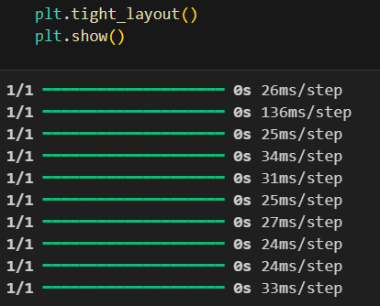
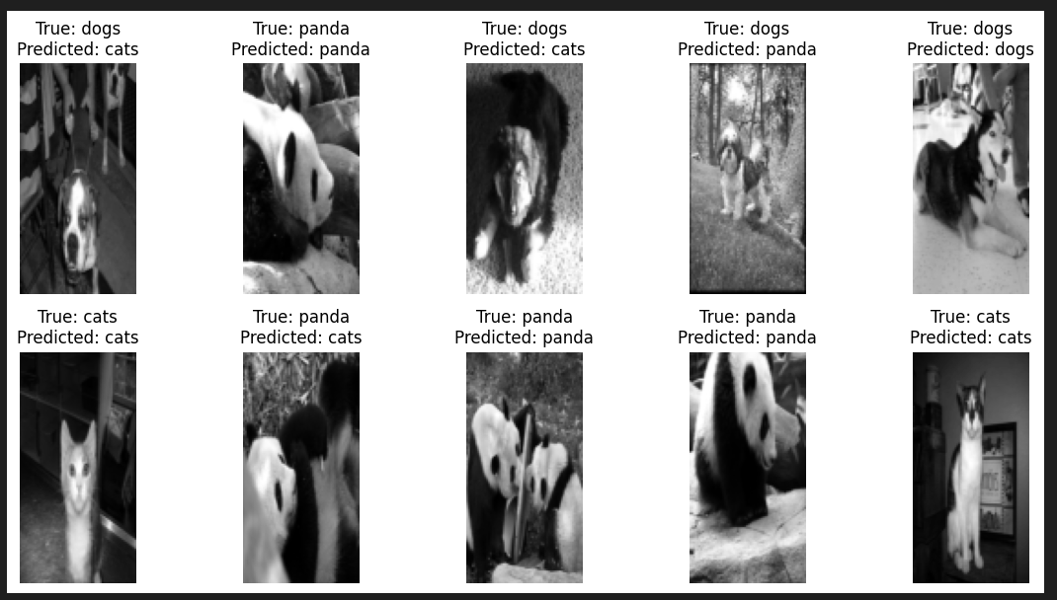
Task 4:
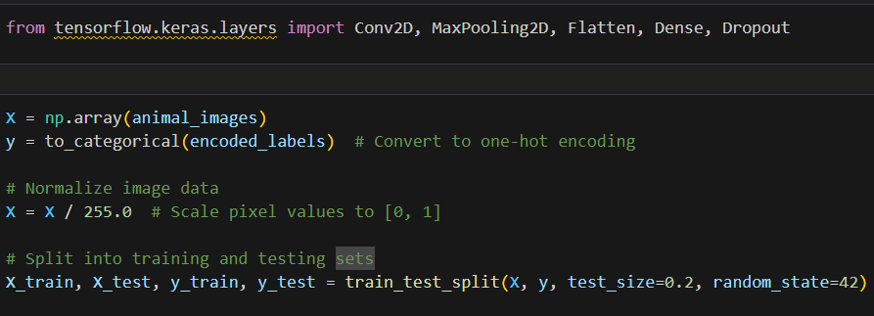
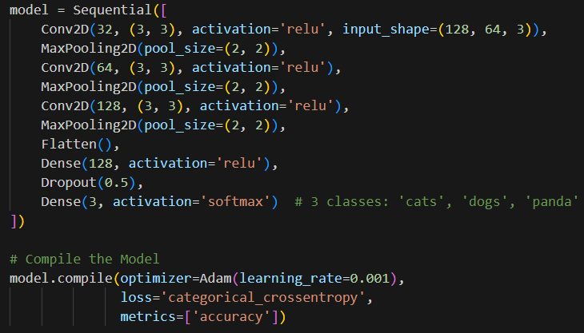
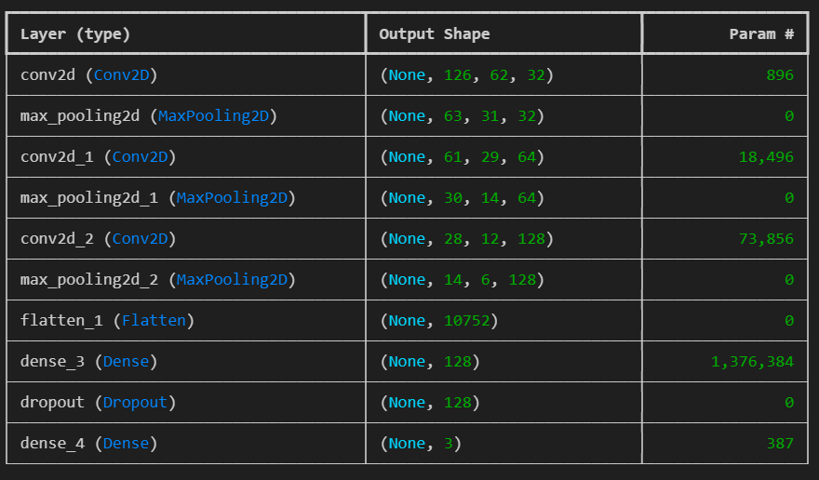
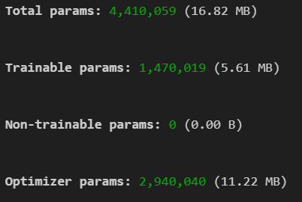
Checking for accuracy:
